**MODULE: 2**

**(CSS and CSS 3)**

**Q1. What are the benefits of using CSS?**

**A1.** Advantages of CSS:

* Consistency

The primary advantage of CSS is that style is consistently used on many web pages. If modifications need to be made, the ability of one command line to manage multiple locations at once is very helpful. Change only one thing, and everything else will fall into place since you don't need to modify each page individually.

* Saves Time

You can write CSS once and reuse the same sheet in multiple HTML pages. You can define a style for each HTML element and apply it to as many web pages as you want.

* Easy maintenance

To make a global change, simply change the style, and all elements in all the web pages will be updated automatically.

* Better website speed

A website should load more quickly to operate effectively. CSS is crucial to the success of businesses that wish to guarantee a faster and smoother website experience.

* Platform Independence

The script offers a consistent platform independence and can support the latest browsers as well

**Q2. What are the disadvantages of CSS?**

**A2.** Disadvantages of CSS:

* Security Issues

In today's technologically and data-driven society, security is crucial. CSS has a restricted level of security, which is one of its main drawbacks.

* Cross-Browser Issues

We can observe that the functionality of different browsers varies. To ensure that modifications made to the website using CSS codes are properly displayed across all browsers, need to be checked.

* Confusion due to many CSS levels

This problem is particularly affecting beginners. Since CSS has numerous levels, including CSS2, CSS3, and others, they could become confused while choosing to study it.

**Q3. What is the difference between CSS2 and CSS3?**

**A3.** The biggest difference between CSS2 & CSS3 is that CSS3 has been split into different sections, called modules. Each of these modules is making its way through the W3C in various stages of the recommendation process.

**Q4. Name a few CSS-style components.**

**A4.** element{

opacity: 0.5;

}

body{

background-color: blue;

}

body{

background-image: url(“image.jpg”);

background-repeat: no-repeat;

}

**Q5. What do you understand by CSS opacity?**

**A5.** In CSS, opacity refers to the level of transparency or the degree to which an element allows light to pass through. It is commonly used to make elements, such as an image or background colors, partially transparent.

The **‘opacity’** property is used to set the opacity of an element and takes a value between 0(completely transparent) and 1(completely opaque). Values between 0 & 1 represent varying degrees of transparency.

Eg: element{

opacity: 0.5;

}

**Q6. How can the background color of an element be changed?**

**A6.** The background color of an element in HTML can be changed using the CSS **‘background-color’** property. This property allows you to set the background color of an element to a specific color.

Eg: body{

background-color: blue;

}

**Q7. How can image repetition of the backup be controlled?**

**A7.** This task can be achieved by using the background-repeat property that will help us to control the repetition of the image. The background-repeat property in CSS is used to repeat the background image both horizontally and vertically. It also decides whether the background image will be repeated or not.

Eg: element{

background-repeat: no-repeat;

}

**Q8. What is the use of the background-position property?**

**A8.** The background-position property sets the starting position of a background image. By default, a background image is placed at an element's top-left corner and repeated vertically and horizontally.

**Syntax:** background-position: value;

Values: left top

left center

left bottom

right top

right center

right bottom

center top

center center

center bottom

If you specify only one keyword other will be center.

Eg: element{

background-position: center top;

}

**Q9. Which property controls the image scroll in the background?**

**A9.** The background-attachment property sets whether the background image scrolls with the rest of the page, or is fixed.

**Syntax:** background-attachment: scroll | fixed |local |initial | inherit;

scroll: The background image will scroll with the page. This is the default.

fixed: The background image will not scroll with the page.

local: The background image will scroll with the element contents.

initial: Sets this property to its default value.

inherit: Inherits this property from its parent element.

Eg: body{

background-image: url(“image.jpg”);

background-repeat: no-repeat;

background-attachment: scroll;

}

**Q10. Why should background and color be used as separate properties?**

**A10.** We should not use background and color properties separately because:

* It enhances the legibility of style sheets. The background property is complex in CSS, and if it is combined with color, the complexity will further increase.
* Color is an inherited property while the background is not. So this can confuse further.

**Q11. How to center block elements using CSS1?**

**A11.** To centrally align the block elements, we can simply make use of the <center> tag. All the elements within the <center> tag will be centrally aligned.

Eg: <center>This is Center Tag.</center>

**Q12. How to maintain the CSS specifications?**

**A12.** The CSS specifications are maintained by the World Wide Web Consortium (W3C). Even though every browser supports CSS, there are many inconsistencies in the supported specification version.

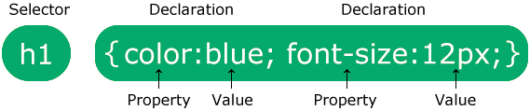

**Q13. What are the ways to integrate CSS as a web page?**

**A13.** CSS may be added to HTML in three different ways.

**Inline CSS:**

To style a single HTML element on the page, use Inline CSS in a style attribute.

<p style=”color: blue;”>This is a Paragraph</p>

**Internal CSS:**

By adding CSS to the head section of our HTML document, we can embed an internal stylesheet.

<head>

<style>

body{

background-color: blue;

}

p{

background-color: blue;

}

</style>

</head>

**External CSS:**

We can also connect to an external stylesheet that separates our CSS from our HTML.

<head>

<link rel=”stylesheet” type=”text/css” href=”style.css”>

</head>

**Q14. What are embedded style sheets?**

**A14.** Embedded Stylesheet also known as **inline Stylesheet** allows you to define styles for a particular HTML document as a whole in one place. This is done by embedding the **<style></style>** tags containing the CSS properties in the head of your document. Embedded style sheets are particularly useful for HTML documents that have unique style requirements from the rest of the documents in your project. However, if the styles need to be applied across multiple documents, you should link to an external style sheet instead of using individual embedded style sheets. Using embedded stylesheets holds a distinct advantage over inline style which only allows you to address one HTML element at a time.

<head>

<style>

body{

background-color: blue;

}

p{

background-color: blue;

}

</style>

</head>

**Q15. What are the external style sheets?**

**A15.** An external style sheet is a separate CSS file that can be accessed by creating a link within the head section of the webpage. Multiple web pages can use the same link to access the stylesheet. The link to an external style sheet is placed within the head section of the page.

<head>

<link rel=”stylesheet” type=”text/css” href=”style.css”>

</head>

**Q16. What are the advantages and disadvantages of using external style sheets?**

**A16.** Advantages of external style sheets:

* With the help of external style sheets, the styles of numerous documents can be organized from one single file.
* In external style sheets, classes can be made for use on numerous HTML element types in many forms of the site.

Disadvantages of external style sheets:

* An extra download is essential to import style information for each file.
* The execution of the file may be deferred till the external style sheet is loaded.
* While implementing style sheets, we need to test Web pages with multiple browsers to check compatibility issues.

**Q17. What is the meaning of the CSS selector?**

**A17.** CSS Selector is a pattern of elements and other terms that tell the browser which HTML elements should be selected to have the CSS property values inside the rule applied to them.

Types of Selectors are as follows:

1. Universal Selector (*)
2. Element Selector
3. Group Element Selector (,)
4. class Selector (.)
5. id Selector (#)
6. Child Selector (>)
7. Adjacent Selector (+)
8. Disandent Selector
9. General Selector (~)

**Q18. What are the media types allowed by CSS?**

**A18.** Media types allowed by CSS are:

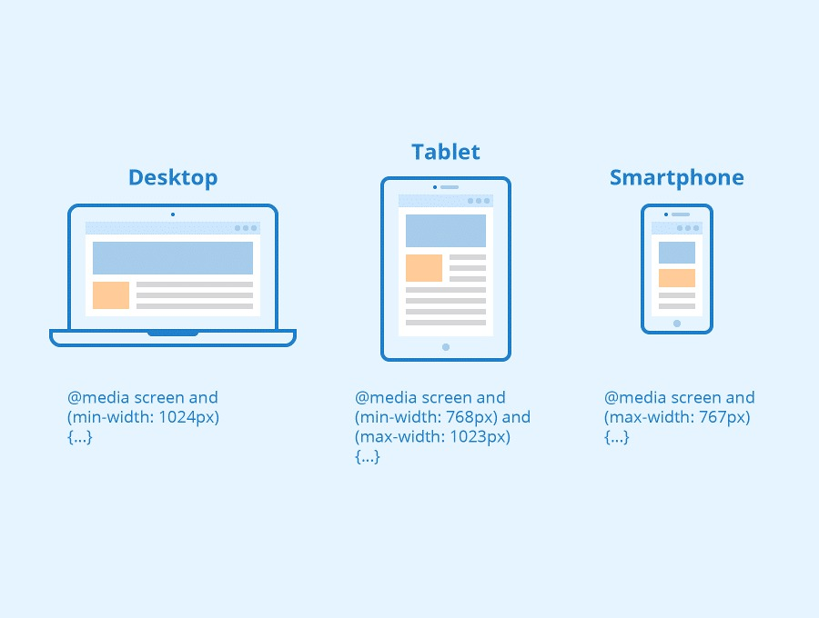

**Q19. What is the rule set?**

**A19.** A CSS ruleset is various affirmations to various pieces or elements of the document.

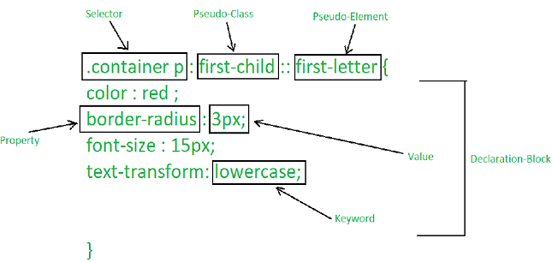

**Q20. Create Layouts**